# [**7 Dream TV Show Crossovers We'd Love to See**](https://www.tvinsider.com/gallery/dream-tv-show-crossovers-ncis-law-order-svu-fbi/)

[***Meredith Jacobs***](https://www.tvinsider.com/author/meredith-jacobs/)SEPTEMBER 28, 2:30 PM



Monty Brinton/CBS; Heidi Gutman/NBC; David Giesbrecht/FOX

While major TV series crossovers have become an annual event for some shared universes, like [**Arrowverse**](http://tvinsider.com/show/arrowverse) and [**One Chicago**](http://tvinsider.com/show/one-chicago), smaller events (like [***Chicago Med***](http://tvinsider.com/show/chicago-med), [***Fire***](http://tvinsider.com/show/chicago-fire), and [***P.D.***](http://tvinsider.com/show/chicago-p-d) have done often) and unlikely ones (like [***Bones***](http://tvinsider.com/show/bones) and [***Sleepy Hollow***](http://tvinsider.com/show/sleepy-hollow) in 2015) are just as fun.

And now, it may not be as easy to have many (or big) crossovers, due to the new guidelines in place for filming in the midst of the coronavirus pandemic. Still, we're hoping to see some team-ups at some point in the near future. Hey, if [***Grey's Anatomy***](https://www.tvinsider.com/show/greys-anatomy/) and [***Station 19***](https://www.tvinsider.com/show/station-19) can pull it off [**for their fall premieres**](https://www.tvinsider.com/949617/greys-anatomy-season-17-station-19-season-4-premiere-crossover/), why not these other shows?

[SEE ALSO](https://www.tvinsider.com/gallery/tv-shows-returning-2021-arrowverse-bachelor/)

### [**'The Bachelor,' 'The Rookie,' 'New Amsterdam' & More TV Faves Not Returning Until 2021**](https://www.tvinsider.com/gallery/tv-shows-returning-2021-arrowverse-bachelor/)

There's still a bit of time before these series return with new seasons.

So, we've gathered our dream crossovers below, from the probable (like something in the [***NCIS***](http://tvinsider.com/show/ncis) franchise and the connected series in that universe) to the least possible (like [***Prodigal Son***](http://tvinsider.com/show/prodigal-son) and [***Brooklyn Nine-Nine***](http://tvinsider.com/show/brooklyn-nine-nine)). Bear in mind, we haven't included the obvious ones like the aforementioned One Chicago series or the [***Law & Order*s**](http://tvinsider.com/show/law-order).

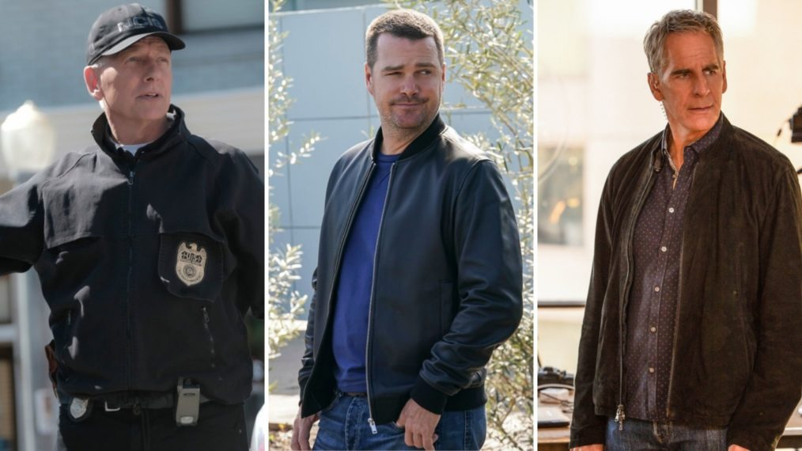

Monty Brinton/CBS (2); Sam Lothridge/CBS

### **Some combination of *NCIS*, *NCIS: LA* & *NCIS: New Orleans* (CBS)**

We haven’t ha nearly as many crossovers as we’d like for this franchise. Whether it’s another smaller crossover, as we’ve seen before with characters crossing over between two of the three, a two-parter like *NCIS* and [***New Orleans***](http://tvinsider.com/show/ncis-new-orleans) have done before, or even a massive three-episode event with all three shows, we’re hoping for something in the 2020-2021 season. (We’ll even take the teams working together on a case with collaboration only over video!)

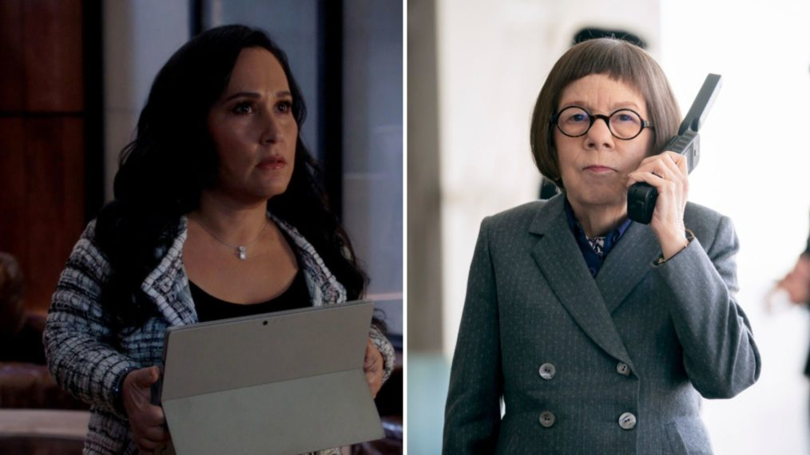

CBS; Erik Voake/CBS

### ***MacGyver*/*NCIS: Los Angeles* (CBS)**

Sure, both shows take place in California, but both also have a tendency to travel for cases. Why not have MacGyver ([**Lucas Till**](http://tvinsider.com/people/lucas-till)) cross paths with the [***L.A.***](http://tvinsider.com/show/ncis-los-angeles) team while they’re on one of their overseas missions, leading to those back in L.A. from both shows joining forces? After all, wouldn’t you love to see Matty ([**Meredith Eaton**](http://tvinsider.com/people/meredith-eaton)) and Hetty ([**Linda Hunt**](http://tvinsider.com/people/linda-hunt)) sit back with a drink at the end of the day to discuss their teams? Both have experience managing employees who don’t always do things by the book.



Courtesy of Warner Bros.; Katie Yu/The CW

### ***DC's Stargirl*/Arrowverse (The CW)**

While the end of “Crisis on Infinite Earths” showed that [***Stargirl***](http://tvinsider.com/show/stargirl) is technically part of the Arrowverse — on the new Earth-2 after the multiverse was rebooted — it is very much separate from the rest of the CW’s superhero shows. Why not change that in its second season, whether via a multi-episode event or even just something much smaller in scope?

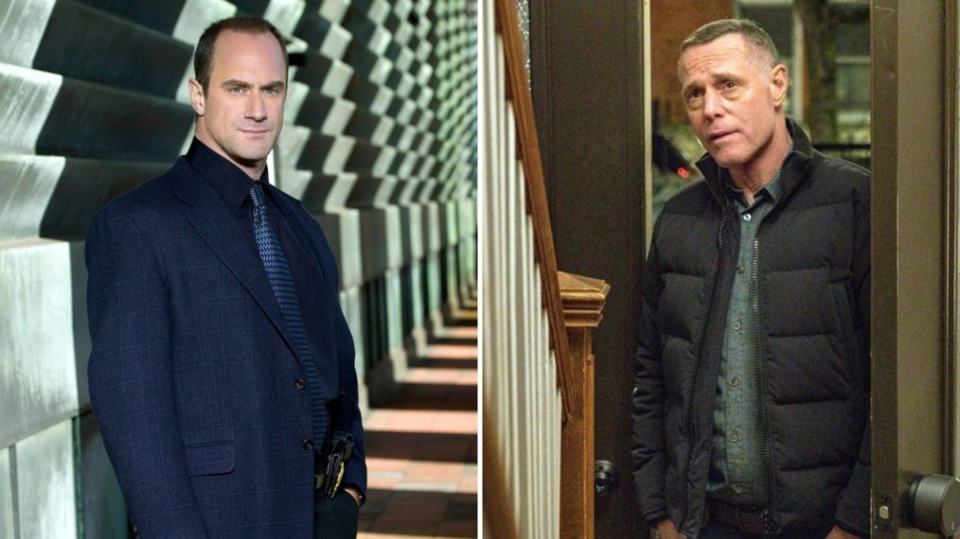

Virginia Sherwood © NBC / Courtesy Everett Collection; Matt Dinerstein/NBC

### ***Chicago P.D.*/*Law & Order: Organized Crime* (NBC)**

Thanks to [***Law & Order: SVU***](http://tvinsider.com/show/law-order-svu) (it’s crossed over with One Chicago), these shows are part of the same universe. While Captain Olivia Benson ([**Mariska Hargitay**](http://tvinsider.com/people/mariska-hargitay)) would likely be the one to connect the two, given she has worked with *P.D.*‘s Sergeant Voight ([**Jason Beghe**](http://tvinsider.com/people/jason-beghe)) and was Elliot Stabler’s ([**Christopher Meloni**](http://tvinsider.com/people/christopher-meloni)) partner, it would be quite interesting to see how those two leaders would inevitably clash if they had to work together *without* her there to mediate.

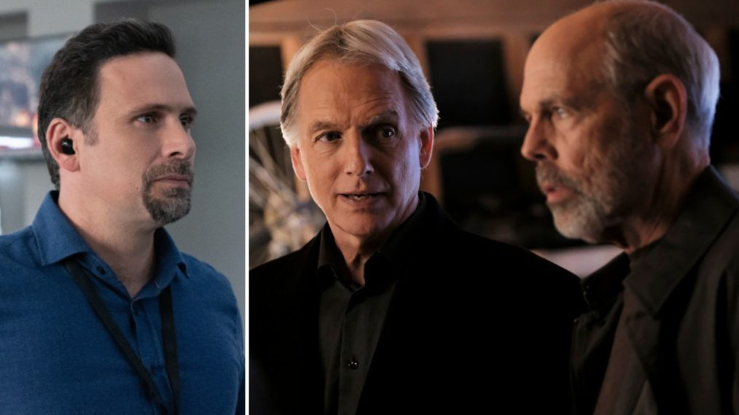

Mark Schafer /CBS; Eddy Chen/CBS

### ***NCIS*/*FBI* (CBS)**

Yes, the schedule does make it pretty easy for a two-part, back-to-back crossover, but we’d also just like to see how Special Agent Leroy Jethro Gibbs ([**Mark Harmon**](http://tvinsider.com/people/mark-harmon)) deals with these FBI agents, given how well that has (not) worked out in the past on *NCIS*. Plus, it could bring in Joe Spano’s Tobias Fornell for a guest spot, as the former FBI agent could have a history with [**Jeremy Sisto’s**](http://tvinsider.com/people/jeremy-sisto) Assistant Special Agent in Charge Jubal Valentine.



Heidi Gutman/NBC; Zach Dilgard/NBC; Virginia Sherwood/NBC

### ***Law & Order: SVU*/*New Amsterdam* (NBC)**

A case would easily bring the squad to the hospital, making things a bit complicated for Dr. Max Goodwin ([**Ryan Eggold**](http://tvinsider.com/people/ryan-eggold)) to succeed in his “how can I help?” Plus, it could be interesting to see Olivia’s desire to help her patient go up against the brash Dr. Cassian Shin ([**Daniel Dae Kim**](http://tvinsider.com/people/daniel-dae-kim)) as he moves from one patient to the next.

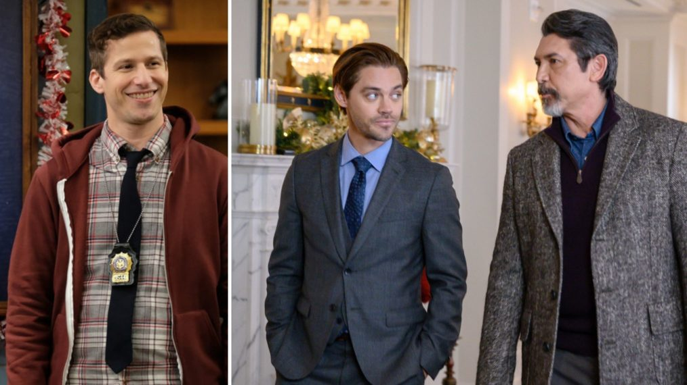

John P. Fleenor/NBC; David Giesbrecht/FOX

### ***Brooklyn Nine-Nine*/*Prodigal Son* (NBC/Fox)**

The chances of this ever happening are pretty much zero, but the utter craziness of Malcolm Bright ([**Tom Payne**](http://tvinsider.com/people/tom-payne)) crossing paths with the squad for a case would be so entertaining. Bonus: [**Andy Samberg’s**](http://tvinsider.com/people/andy-samberg) Detective Jake Peralta could remark that [**Lou Diamond Phillips’**](http://tvinsider.com/people/lou-diamond-phillips) Gil Arroyo looks very familiar. (Phillips guest starred as Jeff Romero in the first two episodes of Season 5 of the NBC comedy.)